



IS480 Project Proposal

SmartHawker

HungryMen

**Team Vision:**

* To take on challenges that feeds our desires to strive for the best

**Team Members:**

* Goh Gui Xiang Wendy ([wendy.goh.2014@sis.smu.edu.sg)](mailto:wendy.goh.2014@sis.smu.edu.sg)) - Project Manager & Front-End Developer
* Kay Zong Wei ([zongwei.kay.2014@sis.smu.edu.sg)](mailto:zongwei.kay.2014@sis.smu.edu.sg)) - Back-End Developer
* Cheng Chingyi ([cycheng.2014@sis.smu.edu.sg)](mailto:cycheng.2014@sis.smu.edu.sg)) - Quality Assurance and Business Analyst
* Gao Min Mell ([min.gao.2014@sis.smu.edu.sg)](mailto:min.gao.2014@sis.smu.edu.sg)) - Front-End Developer
* Chua Weilun ([weilun.chua.2014@sis.smu.edu.sg)](mailto:weilun.chua.2014@sis.smu.edu.sg)) - Back-End Developer and Back/Front End Integration

**Sponsor**: SmartHawker

* Edmund Foo ([edmund@smarthawker.com)](mailto:edmund@smarthawker.com))
* Marcus Lee ([marcus@smarthawker.com](mailto:marcus@smarthawker.com))
* Tan Boon Teck ([boonteck@smarthawker.com)](mailto:boonteck@kidotech.com))

**Project Overview:**

Project Description

SmartHawker iOS mobile application aims to help hawkers in Singapore have access to a free and easy-to-use financial planning tool, so that they can better monitor their business finances, without having to use over-complicated software systems. Local, owner-operated single stall hawkers is the primary target group for this mobile application.

Current Issues

Hawkers in Singapore often rely on manual or semi-manual bookkeeping methods to keep track of their financial records. This is a potential source of problems for them as the lack of accuracy and consistency associated with manual recording methods may lead to incorrect reporting of financial performance, especially when it comes to income tax reporting at the end of each financial year. Hawkers also often do not perform regular cost-benefit analyses as part of their financial decision makings. Instead, they rely on their ‘experience’ or ‘gut feel’ to make such decisions. Hawkers are also usually small sole proprietors and do not typically use POS (Point-of-Sale) systems to log their daily records and track their financials performance.

Aim and Solution

To come up with an iOS mobile application to help hawkers improve their record keeping and business decision making, where their financial information is securely stored and easily accessible for current and future reference, e.g. income tax filing.

**Main Functions:**

|  |  |  |  |
| --- | --- | --- | --- |
| * Authentication | * Password Retrieval | * FAQ | * Parse API |
| * Local iOS Storage | * Contacts for enquiries | * Recording functions | * Analytics |
| * Staff Management/Payment | * Business Calendar | * Backend Admin Dashboard | * Image Capturing |
| * Information used for tax submission | * User Access Control (for employees at multiple branches) | * Multiple Languages (English, Chinese and maybe Malay) | * UI |

|  |  |
| --- | --- |
| Sponsor | Edmund Foo, Marcus Lee, Tan Boon Teck |
| Users | Hawkers |

**Stakeholders**

**Deliverables**

An iOS mobile application and respective documentation.

**Scope**

iOS mobile application: **1)** Swift **2)** Github (Version Control) **3)** Parse Database and Parse API

**Project Plan**

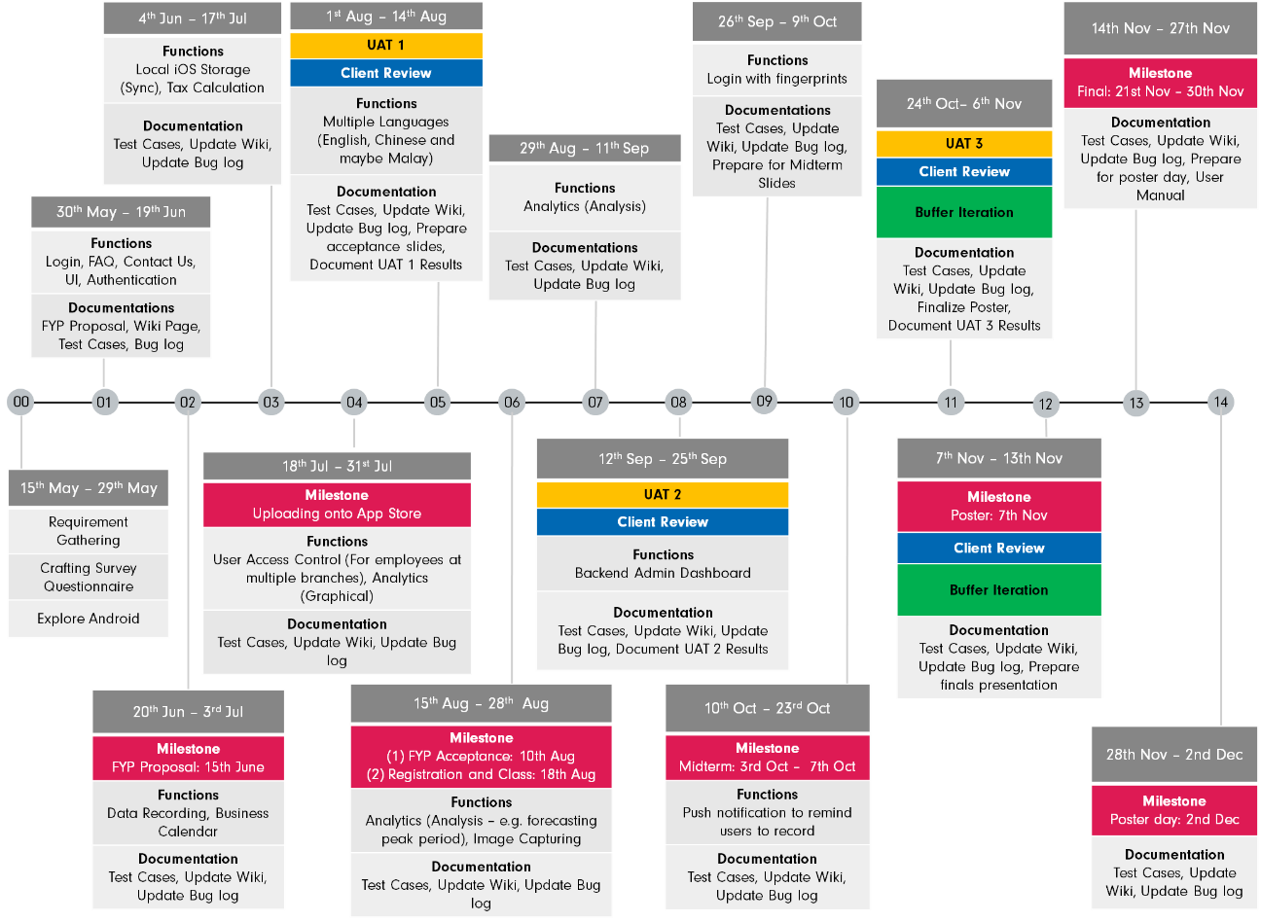

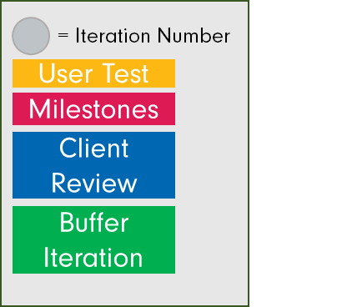

**Risks and Mitigations**

|  |  |
| --- | --- |
| Risk | Mitigation |
| 1. Possibilities of lack of user testing due to insufficient testers | 1. Early management planning and sourcing for users for testing |
| 2. Insufficient collection of data, due to testers not using the mobile application as often as possible | 2. Active monitoring and reminding for users |
| 3. New programming environment for iOS mobile application | 3. Actively learn, research and share programming knowledge with team |
| 4. Possibility of increase in scope of project | 4. Constant review of project scope and constant communication with client to manage expectations of mobile application development |

**Resource and Reference**

1. Programming language: Swift
2. IDE: Xcode
3. Operating System: Mac OS
4. Version Control: Github
5. Database: Parse API